**Understanding - Mathematics for Machine Learning**

Three concepts

* Data
* Model
* Learning

Data is at the core data of machine learning. The goal of machine learning is to design general purpose methodologies to extract valuable patterns from data, ideally without much domain-specific expertise.

Model we design models that are typically related to the process that generates data, similar to the process that generates data. A model is said to learn from data if its performance on a given task improves after the data is considered. The goal is to find good models that generalize well to yet unseen data,

which we may care about in the future.

Learning can be understood as a way to automatically find patterns and structure in data by optimizing the parameters of the model.

Finding Words for Intuitions

* Predictors
* Training
* Data as vectors
* Model
* Learning

Predictors

-In the first sense, we use the phrase “machine learning algorithm” to mean a system that makes predictions based on inpredictors put data. We refer to these algorithms as predictors.

In the second sense, we use the exact same phrase “machine learning algorithm” to mean a system that adapts some internal parameters of the predictor so that it performs well on future unseen input data. Here we refer to this adaptation as **training** a system.

Data as vectors

We assume that data has already been appropriately converted into a numerical representation suitable for reading into a computer program. Therefore, we think **of data as vectors**. As another illustration of how subtle words are, there are (at least) three different ways to think about vectors: **a vector as an array of numbers (a computer science view), a vector as an arrow with a direction and magnitude (a physics view), and a vector as an object that obeys addition and scaling (a mathematical view).**

Models

A model is typically used to describe a process for generating data, similar

to the dataset at hand. Therefore, good models can also be thought of simplified versions of the real (unknown) **data-generating process, capturing aspects that are relevant for modeling the data and extracting hidden patterns from it**. A good model can then be used to predict what would happen in the real world without performing real-world experiments.

Learning

Training the model means to use the data available to optimize some parameters of the model with respect to a utility function that evaluates how well the model predicts the training data. Most training methods can be thought of as an approach analogous to climbing a hill to reach its peak. In this analogy, the peak of the hill corresponds to a maximum of some desired performance measure.

Performing well on data that we have already seen (training data) may only mean that we found a good way to memorize the data. However, this may not generalize well to unseen data, and, in practical applications, we often need to expose our machine learning system to situations that it has not encountered before.

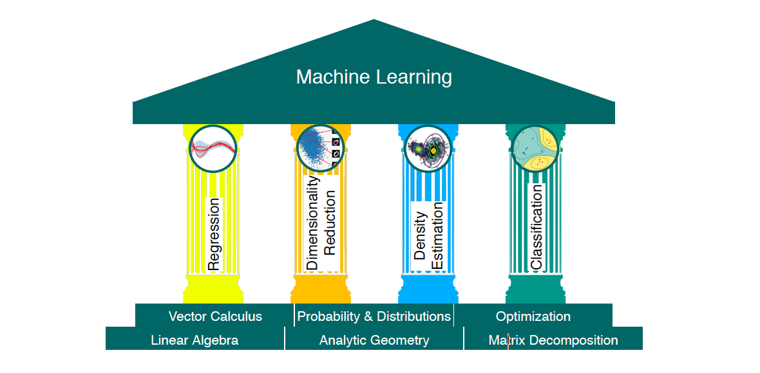

2.Linear Algebra

Linear algebra is the study of vectors and certain algebra rules to manipulate vectors. The vectors many of us know from school are called “geometric vectors”, which are usually denoted by a small arrow above the letter.

In general, vectors are special objects that can be added together and multiplied by scalars to produce another object of the same kind. From an abstract mathematical viewpoint, any object that satisfies these two properties can be considered a vector. Here are some examples of such vector objects:

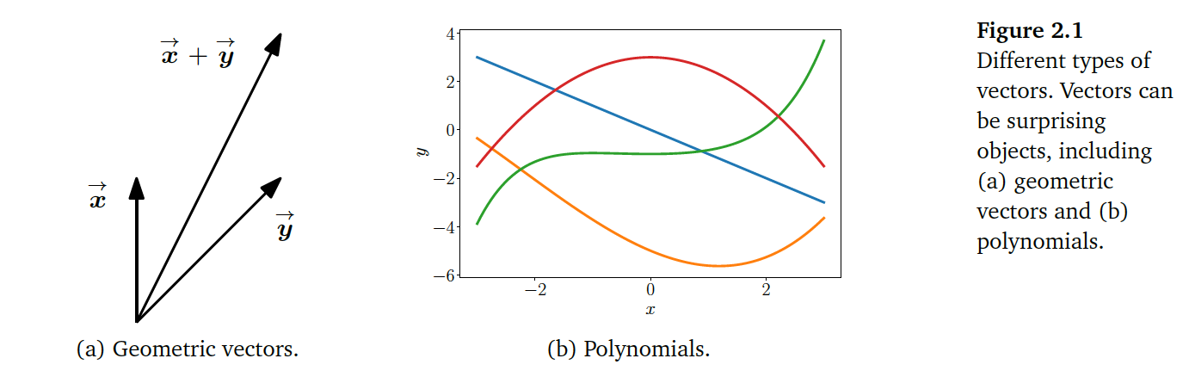

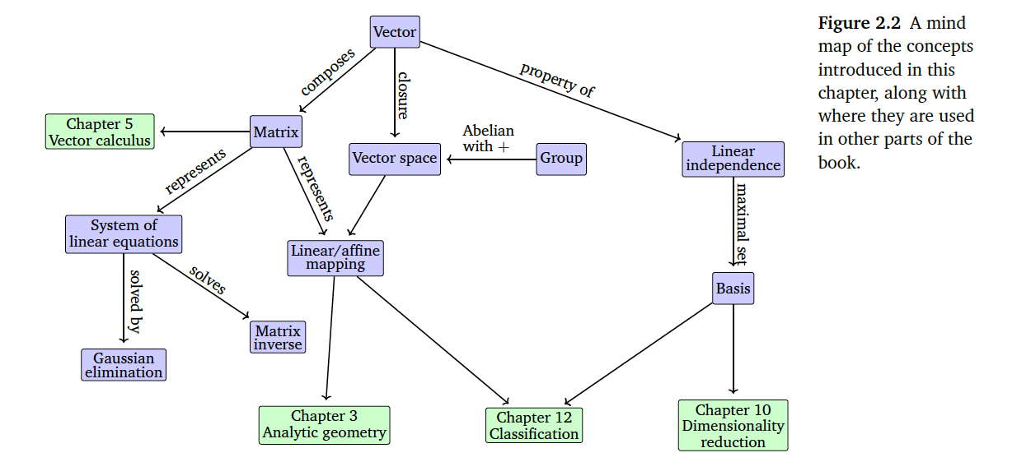

2.1 Systems of Linear Equations